**SCHOOL OF COMPUTER SCIENCE**

**UNIVERSITY OF PETROLEUM AND ENERGY STUDIES**

**DEHRADUN, UTTARAKHAND**



**IT DATA SECURITY LAB**

**LABORATORY FILE**

**(2024-2025)**

**For**

**Vth Semester**

**Submitted To: Submitted By:**

Dr. Narendra Kumar Dewangan Mr. Akshat Negi

Assistant Professor S.S. 500106533(SAP ID)

[Vth Semester] R2142220414(Roll No.)

School of Computer Sciences B.Tech. CSF (Batch-1)

**LAB EXPERIMENT – 2**

**FIREWALL**

In Kali Linux, several firewall tools are available to help secure your system. Below are some common firewall software options in Kali Linux:

**1.** UFW (Uncomplicated Firewall)

* **Description:** UFW is a front-end for iptables, designed to make managing a firewall easier.

**Installation:**

sudo apt-get install ufw

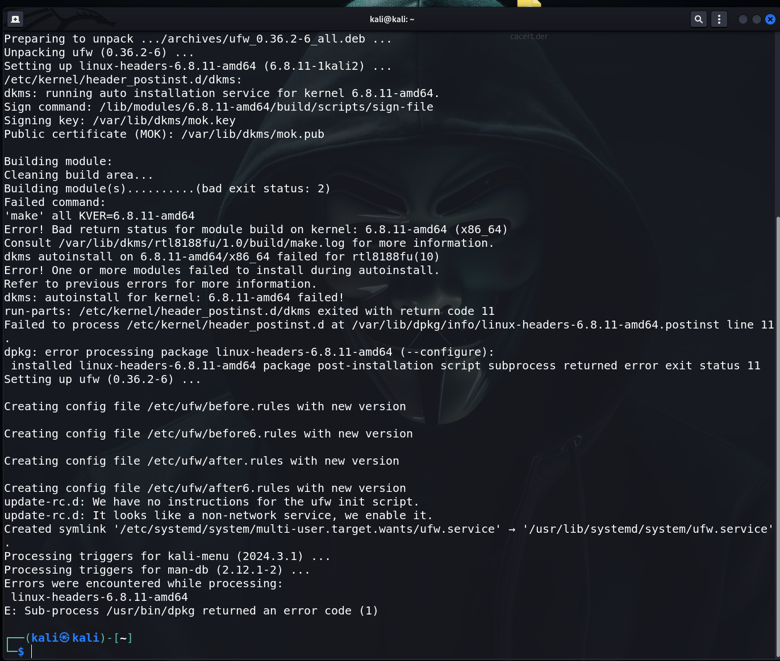

* **Basic Commands:**
  + Enable UFW:

sudo ufw enable

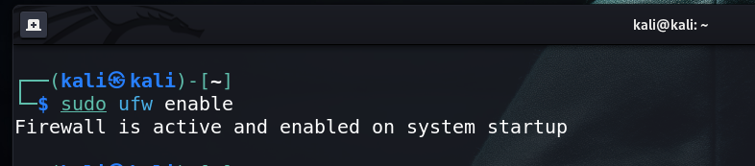

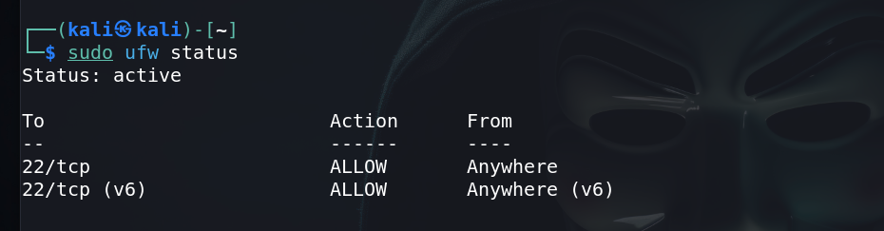

* + Allow specific port (e.g., SSH on port 22):

sudo ufw allow 22/tcp

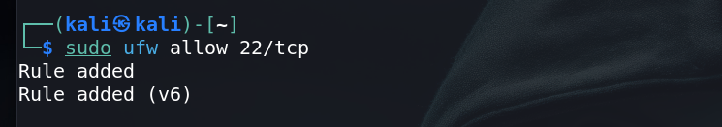

* + Deny a specific port:

sudo ufw deny 80/tcp

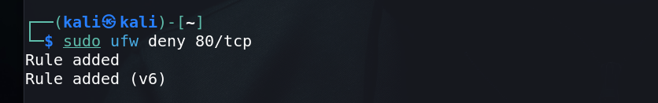

* + Check status:

sudo ufw status

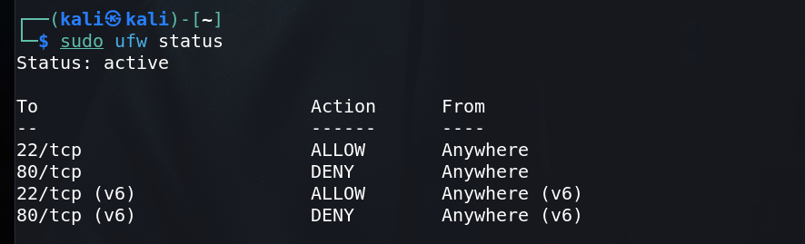

**2.** iptables

* **Description:** iptables is a command-line utility for configuring Linux kernel firewall implemented within the Netfilter project. It's more advanced and flexible than UFW.
* **Basic Commands:**
  + List current rules:

sudo iptables -L

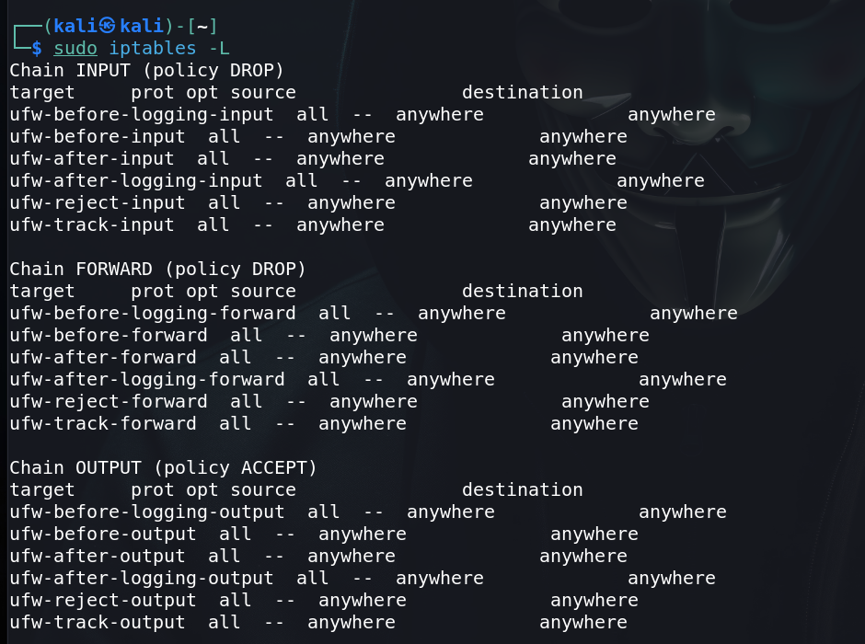

* + Allow a specific port (e.g., HTTP on port 80):

sudo iptables -A INPUT -p tcp --dport 80 -j ACCEPT

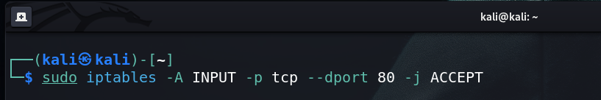

* + Block a specific IP address:

sudo iptables -A INPUT -s 192.168.1.100 -j DROP

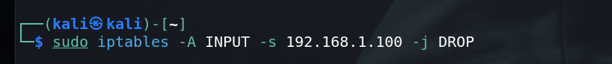

* + Save rules:

sudo iptables-save > /etc/iptables/rules.v4

**3.** Firewalld

* **Description:** Firewalld is a firewall management tool that supports both IPv4 and IPv6 firewall settings. It provides a dynamically managed firewall with support for network/firewall zones to define the trust level of network connections or interfaces.
* **Installation:**

sudo apt-get install firewalld

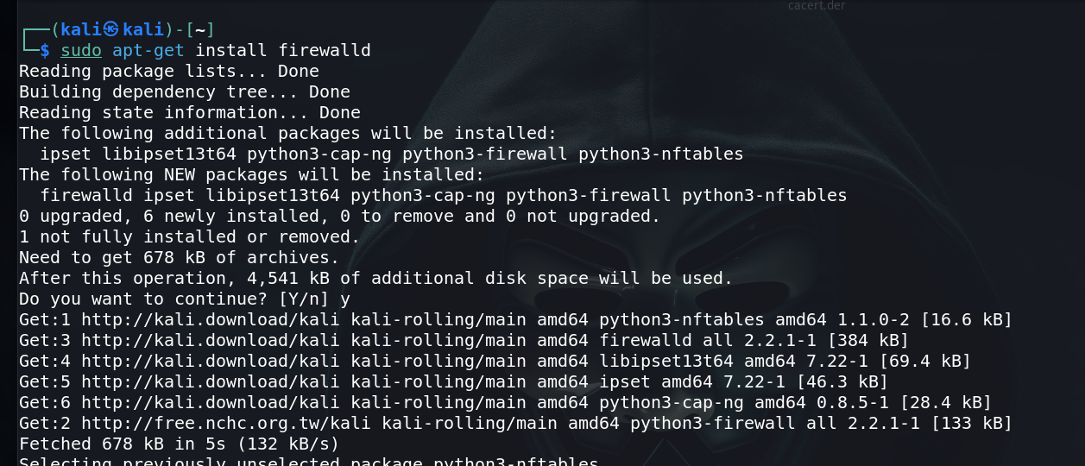

* **Basic Commands:**
  + Start Firewalld:

sudo systemctl start firewalld

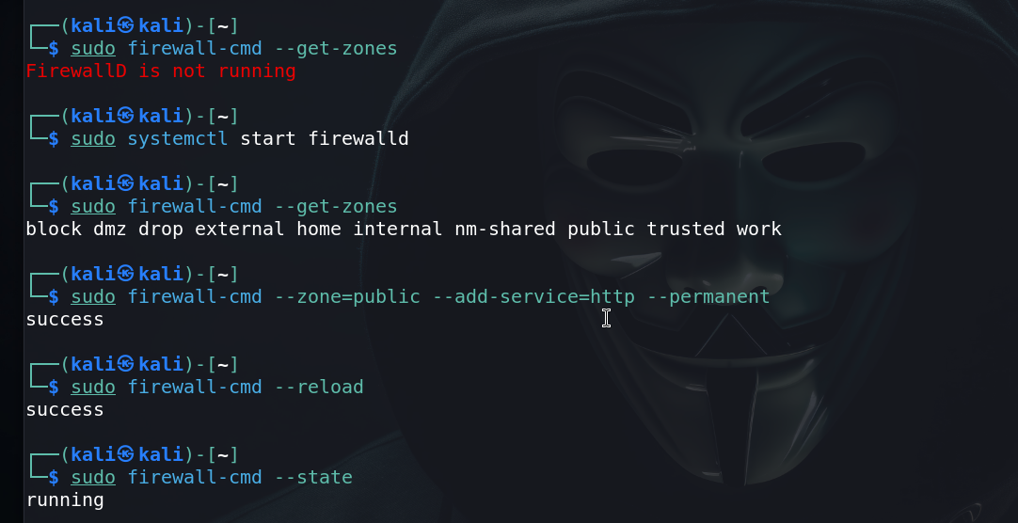

* + Enable Firewalld on boot:

sudo systemctl enable firewalld

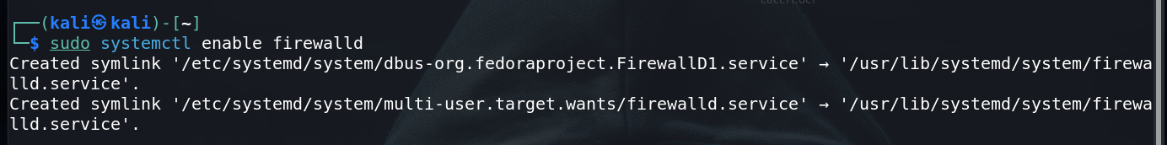

* + List all available zones:

sudo firewall-cmd --get-zones

* + Allow a service (e.g., HTTP) in the public zone:

sudo firewall-cmd --zone=public --add-service=http --permanent

sudo firewall-cmd –reload

* + Check the status of the firewall:

sudo firewall-cmd –state



**4.** GUFW (Graphical Interface for UFW)

* **Description:** GUFW is a graphical user interface for UFW, making it even easier for beginners to configure their firewall.
* **Installation:**

sudo apt-get install gufw

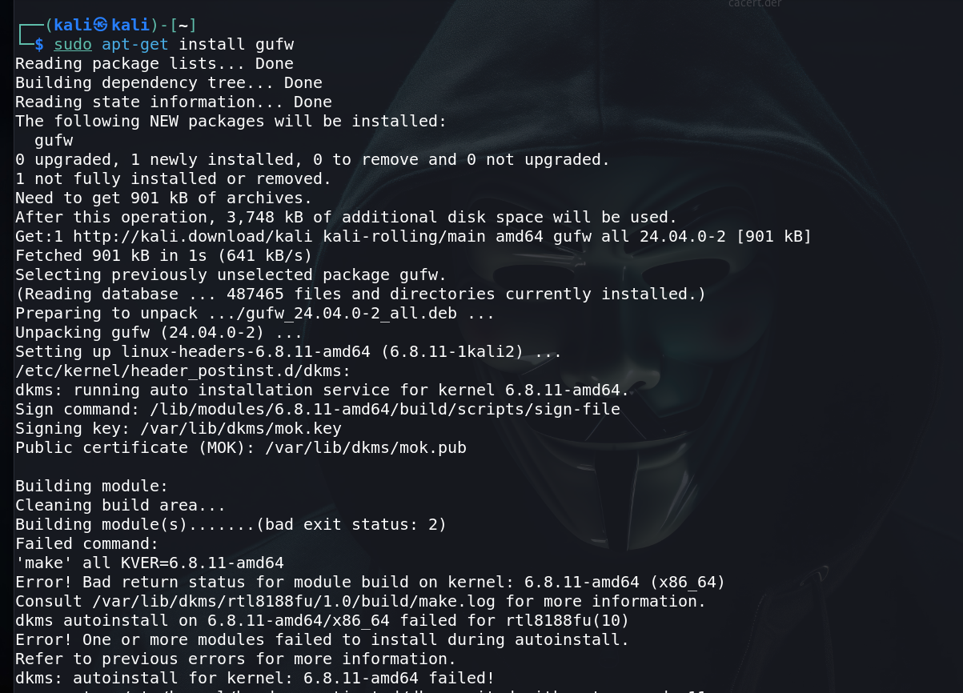

* **Usage:**
  + After installation, you can launch GUFW from the applications menu and use its simple interface to enable/disable the firewall, allow/deny ports, and manage rules.



**5.** OpenSnitch

* **Description:** OpenSnitch is an application firewall for Linux, similar to the macOS application Little Snitch. It monitors outgoing connections and allows you to block or allow them.
* **Installation:**

sudo apt-get install opensnitch

* **Usage:**
  + Once installed, OpenSnitch runs in the background and prompts you whenever an application tries to make an outgoing connection.

**Firewall Configuration and Vulnerability Finding in Kali Linux**

Kali Linux provides a robust environment for configuring firewalls and finding vulnerabilities. Below is a guide to configuring a firewall using iptables and UFW, and finding vulnerabilities using tools like Nmap and OpenVAS.

1. Firewall Configuration

A. Configuring the Firewall with **iptables**

iptables is a powerful tool for configuring network packet filtering rules. Here’s how you can set up a basic firewall:

* **Step 1: View Current Rules**

sudo iptables -L



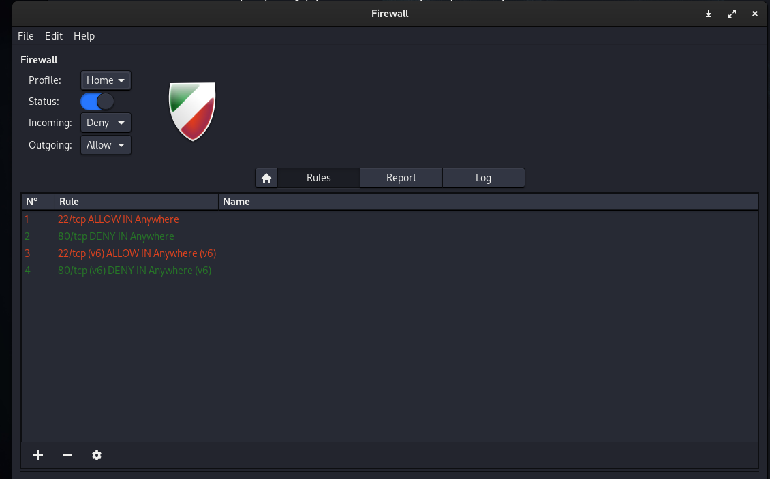

* **Step 2: Flush Existing Rules** If you want to start fresh, clear all existing rules:

sudo iptables -F

* **Step 3: Set Default Policies** Set the default policies to drop all incoming and forwarding traffic, while allowing outgoing traffic:

sudo iptables -P INPUT DROP

sudo iptables -P FORWARD DROP

sudo iptables -P OUTPUT ACCEPT

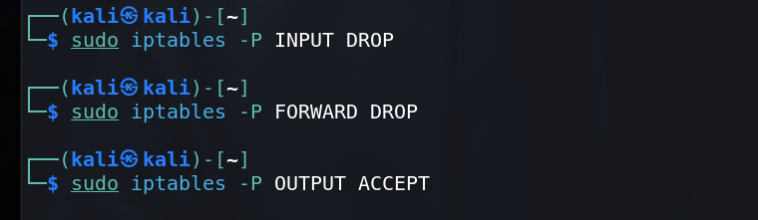

* **Step 4: Allow SSH Access** Allow SSH traffic on port 22:

sudo iptables -A INPUT -p tcp --dport 22 -j ACCEPT

* **Step 5: Allow Traffic on Specific Ports** Allow HTTP (port 80) and HTTPS (port 443) traffic:

sudo iptables -A INPUT -p tcp --dport 80 -j ACCEPT

sudo iptables -A INPUT -p tcp --dport 443 -j ACCEPT

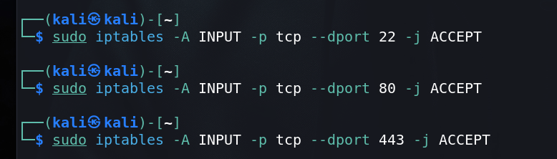

* **Step 6: Allow Traffic from Localhost** Allow traffic from the loopback interface:

sudo iptables -A INPUT -i lo -j ACCEPT

* **Step 7: Allow Established Connections** Allow established and related incoming connections:

sudo iptables -A INPUT -m conntrack --ctstate ESTABLISHED,RELATED -j ACCEPT

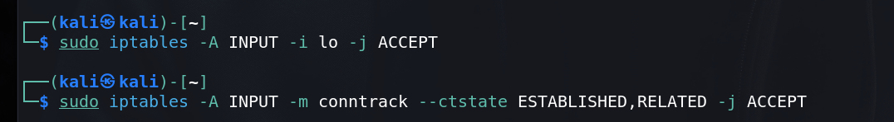

* **Step 8: Save the Rules** Save the configured rules so they persist after reboot:

sudo iptables-save > /etc/iptables/rules.v4

B. Configuring the Firewall with **UFW**

UFW (Uncomplicated Firewall) simplifies firewall management:

* **Step 1: Install UFW** UFW may already be installed on Kali. If not:

sudo apt-get install ufw



* **Step 2: Set Default Policies** Set default policies to deny incoming traffic and allow outgoing traffic:

sudo ufw default deny incoming

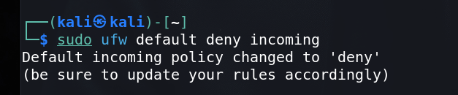

sudo ufw default allow outgoing

* **Step 3: Allow Specific Ports** Allow SSH, HTTP, and HTTPS traffic:

sudo ufw allow 22/tcp

sudo ufw allow 80/tcp

sudo ufw allow 443/tcp

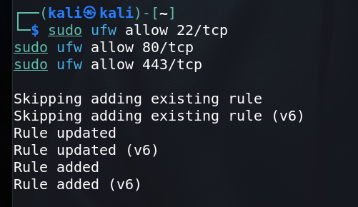

* **Step 4: Enable UFW** Enable UFW to activate the firewall:

sudo ufw enable



* **Step 5: Check UFW Status** Check the status of UFW and the rules configured:

sudo ufw status verbose

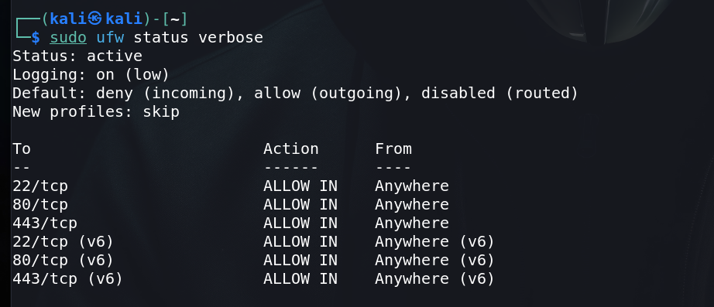

2. Vulnerability Finding

A. Vulnerability Scanning with **Nmap**

Nmap is a powerful network scanning tool that can be used to find open ports and potential vulnerabilities:

* **Step 1: Basic Host Scan** Scan a single host to find open ports:

sudo nmap -sS [target IP]

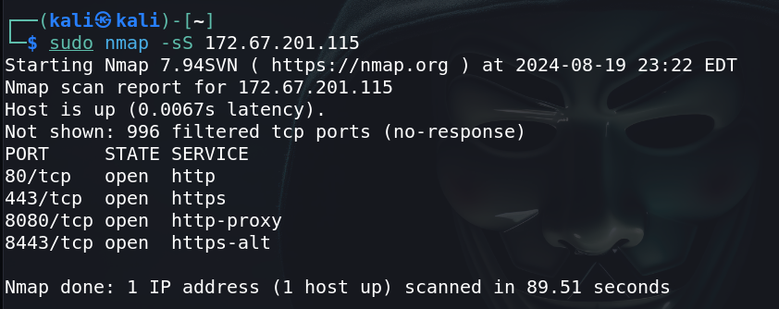

* **Step 2: Version Detection** Detect versions of services running on open ports:

sudo nmap -sV [target IP]

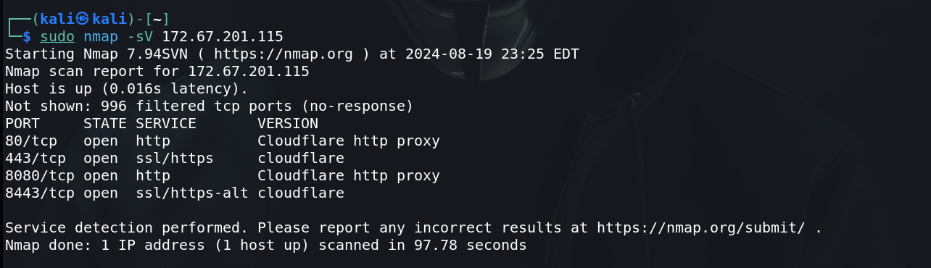

* **Step 3: Operating System Detection** Identify the target’s operating system:

sudo nmap -O [target IP]

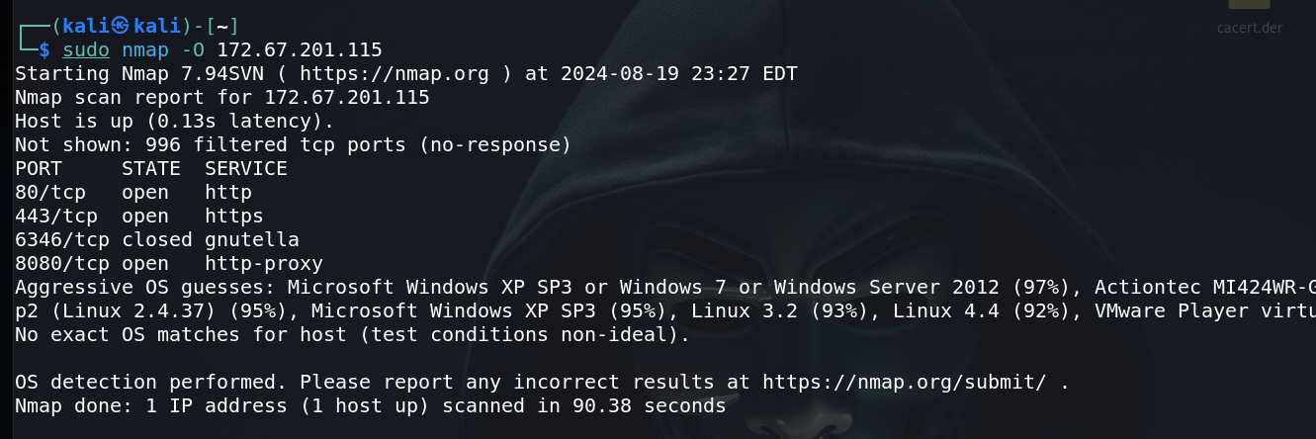

* **Step 4: Full Network Scan** Scan an entire subnet:

sudo nmap -p- [target IP range]

* **Step 5: Vulnerability Scripts** Use Nmap scripts to detect vulnerabilities:

sudo nmap --script vuln [target IP]

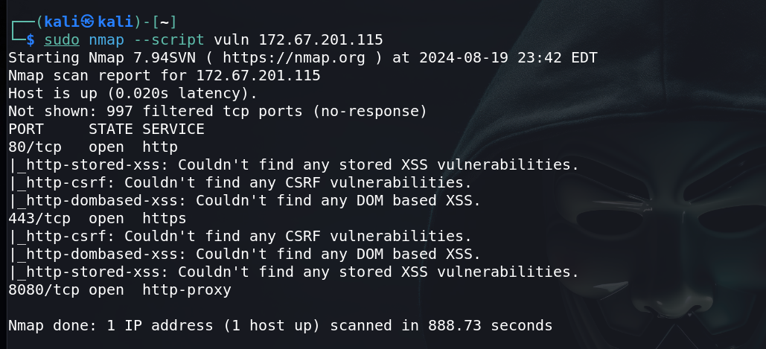

B. Vulnerability Scanning with **OpenVAS**

OpenVAS is a full-featured vulnerability scanner that’s part of the Greenbone Vulnerability Management (GVM) solution.

* **Step 1: Install and Setup OpenVAS** Install and set up OpenVAS on Kali Linux:

sudo apt-get update

sudo apt-get install openvas

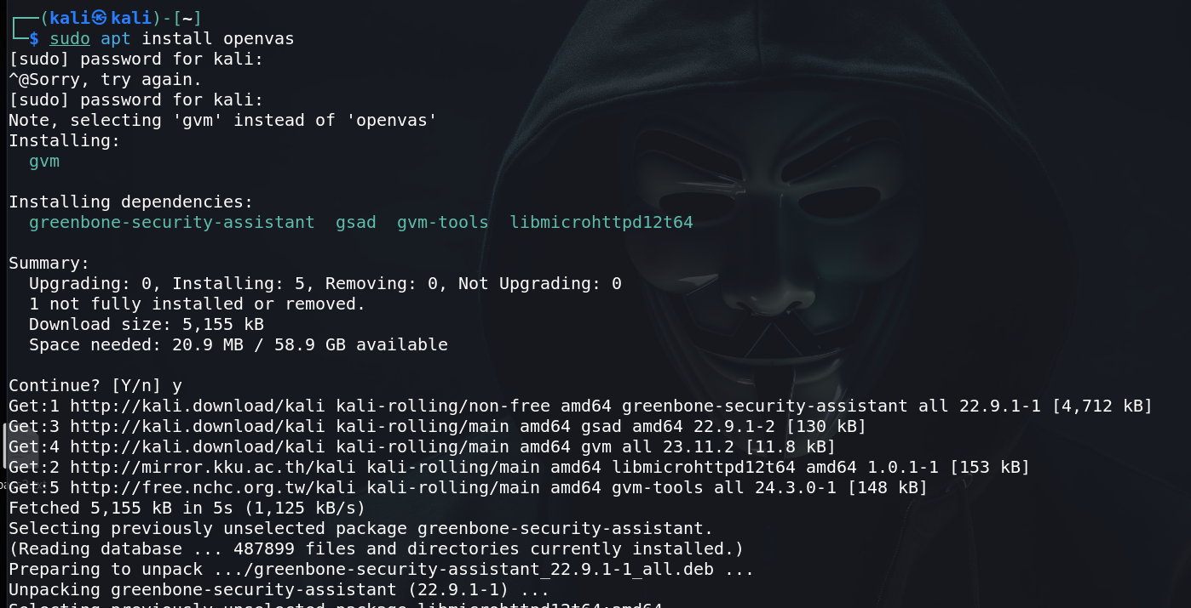

sudo gvm-setup

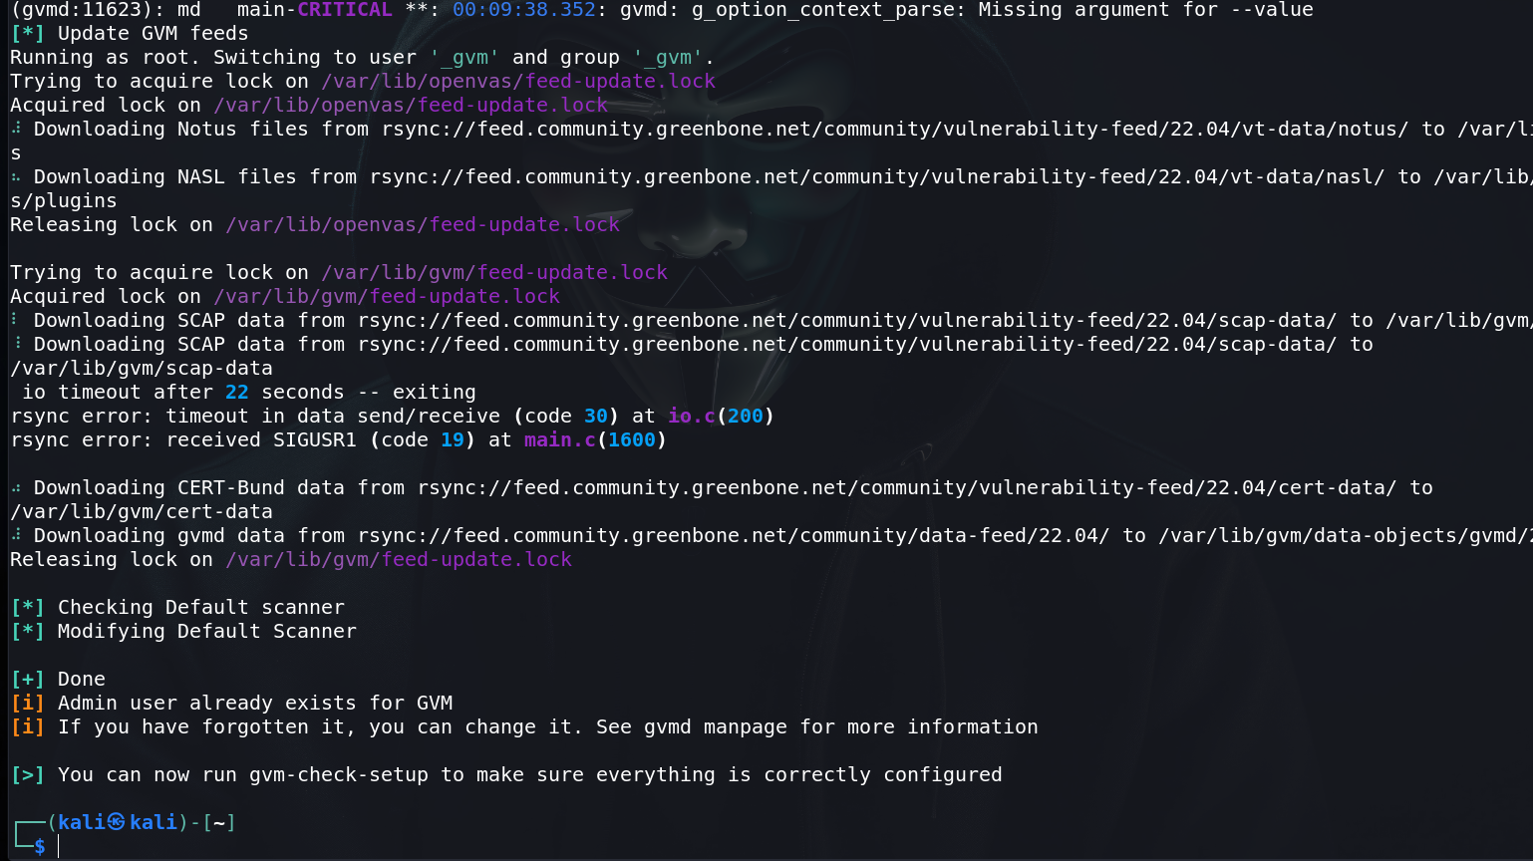

* **Step 2: Start OpenVAS Services** Start the OpenVAS services:

sudo gvm-start

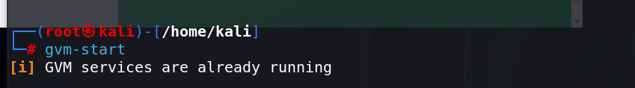

* **Step 3: Access OpenVAS Web Interface** Access the OpenVAS web interface through your browser:

<https://127.0.0.1:9392>

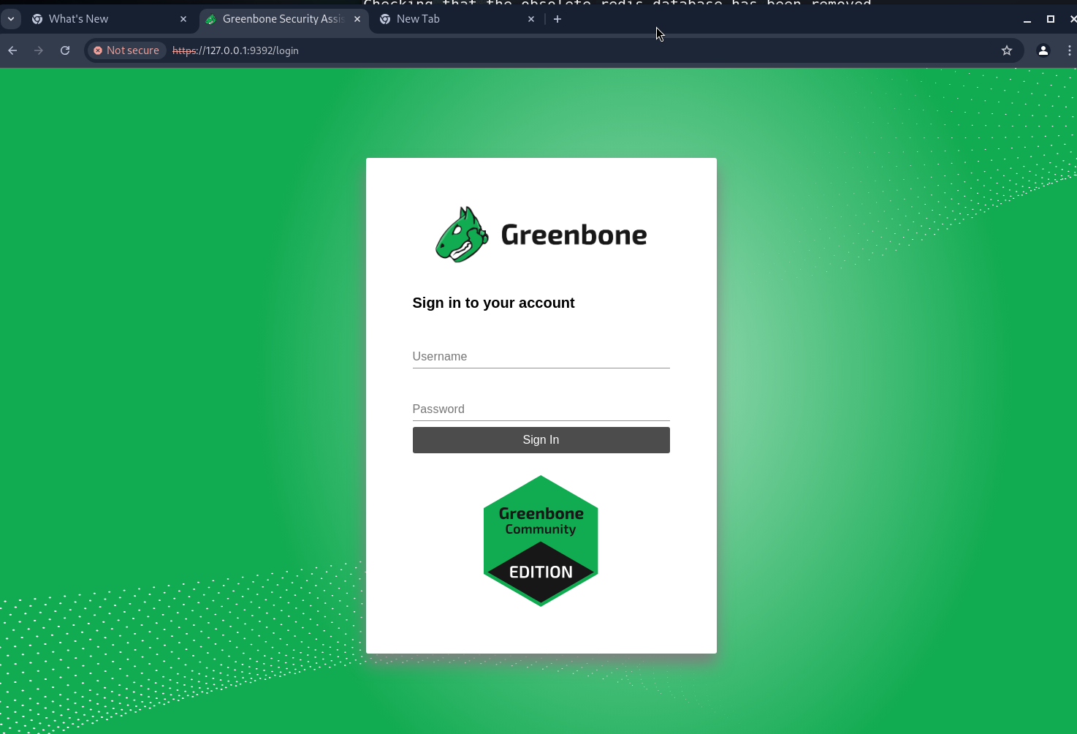

Log in using the credentials provided during the setup.

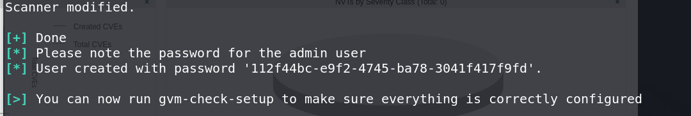

* **Step 4: Create and Run a Scan**
  1. Go to "Scans" in the web interface.
  2. Create a new scan target and specify the IP address or range.
  3. Launch the scan and wait for it to complete.

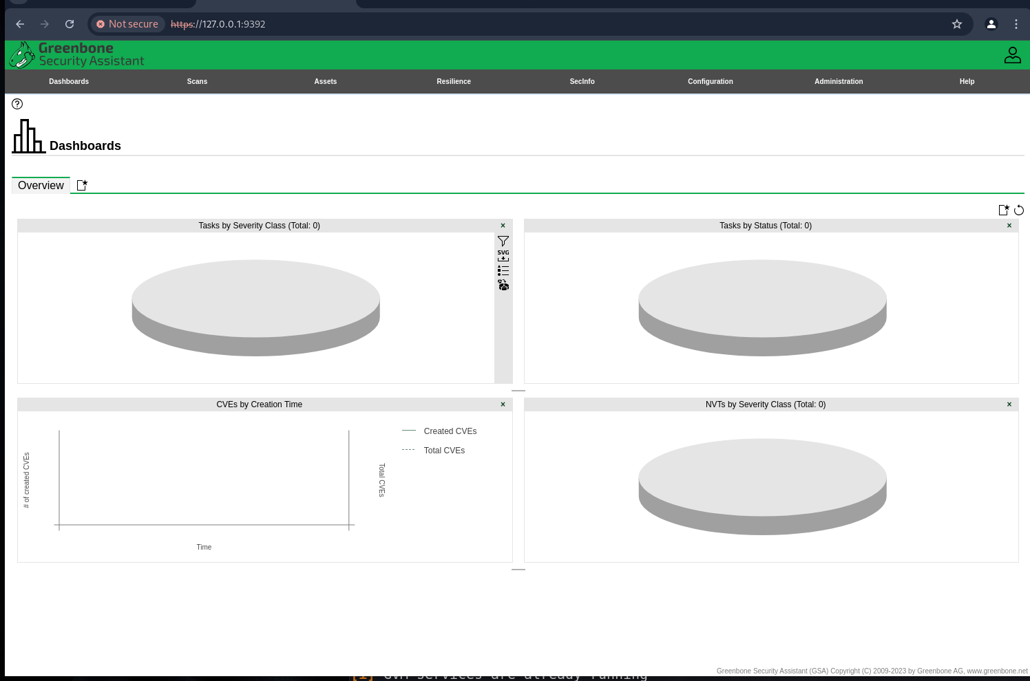

* **Step 5: Analyze the Scan Report** Review the scan report for vulnerabilities and recommended mitigations.

C. Other Vulnerability Tools

Consider using additional tools like:

* **Nessus**: Another popular vulnerability scanner that can be installed on Kali Linux.
* **Nikto**: A web server scanner that tests for vulnerabilities in web applications